Chewelah ARTS Guild
ARTS IN SCHOOLS PROGRAM

OVERVIEW:
The Arts in Schools Program expands Art experiences to more area children with classroom-based lessons provided by local Arts Instructors.
Lessons in the Program inspire aspiring young art students.

PROGRAM DETAILS:
- Artist Instructor/Specialist APPLICATION includes:
Overview of school requirements for vetting
Description of prior experience
Lesson Plan, including classroom time needed for lesson/project
Preferred student age/grade level
Budget for materials
List of other Art Projects/Lesson Plans for future classes

- Artist Instructor REGISTRY lists Artists and classroom lessons they offer.
This allows schools and teachers to choose from Artist Instructors who match their student learning goals.

- PROGRAM COORDINATORS:
Gail Churape: gail.churape@gmail.com, 509.936.0076
Susanne Griepp: sgriepp65@gmail.com, 509.640.0176

POTENTIAL ARTS LESSONS OFFERED:
Watercolor, Collage, Printmaking, Graphic Art, Murals, Poetry/Writing, Clay, Fiber Art, Movement/Dance, Drumming/Musicmaking, Photography, etc.

Chewelah Arts Guild ARTS IN SCHOOLS PROGRAM
Overview for Artist Instructors:

Hourly pay:
Artist Instructors will be paid $35 for each classroom hour of instruction.

Materials:
The Chewelah Arts Guild is willing to pay for some materials that schools and Classroom Teachers and Artist Instructors cannot provide.

Artist Instructor Packet:
Forms to be completed by Artist Instructor for each project are:
- Artist Instructor Application
- Billing Invoice
- Artist Instructor Evaluation

Requirements:
The Chewelah School District requires all volunteers and Artist Instructors working in classrooms to fill out a Volunteer Form and pass a background check. This is available in the Chewelah School District Office located on the corner of Webster Ave. and Park Ave./Hwy 395 (across from Rancho Chico).

Co-Coordinators intend to respond within one week to confirm that proposals have been granted.
Program Coordinators:
Gail Churape: gail.churape@gmail.com, 509.936.0076
Susanne Griepp: sgriepp@gmail.com, 509.640.0176

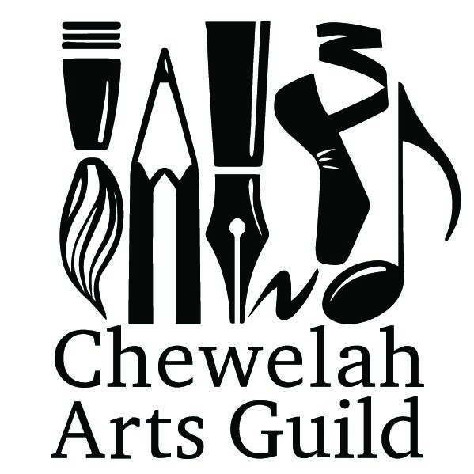
Chewelah Arts Guild
PO Box 1437, Chewelah, WA 99109
www.chewelahartsguild.org
Program Coordinators: Gail Churape, gail.churape@gmail.com, 509.936.0076
Susanne Griepp, sgriepp65@gmail.com, 509.640.0176

ARTS IN SCHOOLS
Artist Instructor Application

Name:
Phone:
Address:
Email:
Planned Art Lesson:

Classroom Time:
Art/Medium:
Budget:
Supplies Needed and/or Provided:

Do you require a special space/setting? If yes, where? ________________________________________
Student Age/Grade Level Preference:

Artist Instructor Prior Instruction Experience: (if more space needed, attach info to this form)

Possible Future Lesson Plans: (if more space needed, attach additional info to this form)

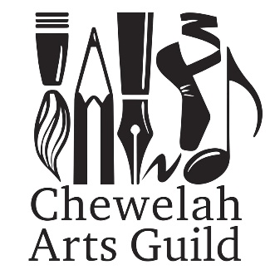 Billing Invoice for Arts in Schools Program

Submit Bill to: Chewelah Arts Guild
PO Box 1437
Chewelah, WA 99109

Artist Instructor: _____________________________________Name (please print)
________________________________________ Mailing Address
________________________________________ City, State, Zip code
Date(s) of services in School: __________________________________________
School where services were provided: ___________________________________
Name of Project: ____________________________________________________
Number of Hours worked in the School: __________________________________
Supplies purchased by Artist: __________________________________________
__________________________________________________________________
__________________________________________________________________
Cost of Supplies purchased by Artist needing reimbursement: ________________
(Copies of Supplies Receipts must be attached)

_____________________________________________________________________________________
Artist’s signature Date

